Lab 9
Adrian Corrales (ac86223)
18595 Thursday 11a-2p

Introduction:
MOSFET amplifier stages are characterized by their biasing and small signal operation. A common source stage provides voltage gain at the drain, while a common drain acts like a buffer that has a low output impedance allowing it to drive loads without a significant voltage drop. This is important when the load requires significant current, like an LED whose brightness depends on the current that flows through it. By combining these two stages, the circuit can amplify an input signal and supply enough current to a load without changing the operating point.
Components:
The same components listed in the lab instructions were used.

Procedure:
The same procedure described in the lab instructions were followed.

Results and Discussion:

Task 1:
1. The semiconductor compound used to form the PN junction determines the wavelength of the emitted light, which is what determines the color output of the LED.

3.
Voltage for Turning on LED | Green | Red
100 ohms | 1.9 V | 1.7 V
500 ohms | 1.9 V | 1.7 V

Voltage for high brightness of LED | Green | Red
100 ohms | 2.9 V | 2.4 V
500 ohms | 3.2 V | 2.9 V

4.
Resistor | 100 ohms | 500 ohms
(Red) I load | (2.1-1.7)/100 = 4 mA | (2.5-1.7)/500 = 1.6 mA
(Green) I load | (2.2-1.9)/100 = 3 mA | (2.7-1.9)/500 = 1.6 mA
5. Higher resistor value means lower current means higher max voltage for max brightness
6. The green LED requires higher voltage to turn on and to reach max brightness, would need to have a lower resistor value to match red LED.
7. The first stage is a common source amplifier with DC bias, and the second stage is a common drain or source follower. The first stage is used to provide a voltage gain, and the second stage is used to drive the LED with a low output impedance.

Task 2:
Both MOSFETS have a Vth of 1.5 V
2.
Resistor | 100 ohms | 500 ohms
Vg2 | 3.7 V | 4 V

3.
Resistor | 100 ohms | 500 ohms
Rd | 1300 | 1000

4.
Voltage | 100 ohms | 500 ohms
Vg1 | 1.39 V | 1.39 V

5.
Resistors | R = 100 ohms | R = 500 ohms
R1 | 26000 | 26000
R2 | 10000 | 10000

6.
 | Rd = 1300 ohms | Rd = 1000 ohms
Stage 1: Av = -gmRd | -13 | -10
Stage 2: Av = gmRs/1+gmRs | .9 | .98

7. C = 1/((2pi)(1000)(7222)) = 0.02 μF

8.
Voltage | 100 ohms | 500 ohms
Vgs1 | 1.39 V | 1.39 V
Vds1 | 3.4 V | 3.8 V

9.
Voltage | 100 ohms | 500 ohms
Vs2 | 2.1 V | 2.35 V
Vds2 | 2.9 V | 2.65 V
Vgs2 | 1.38 V | 1.37 V

11.
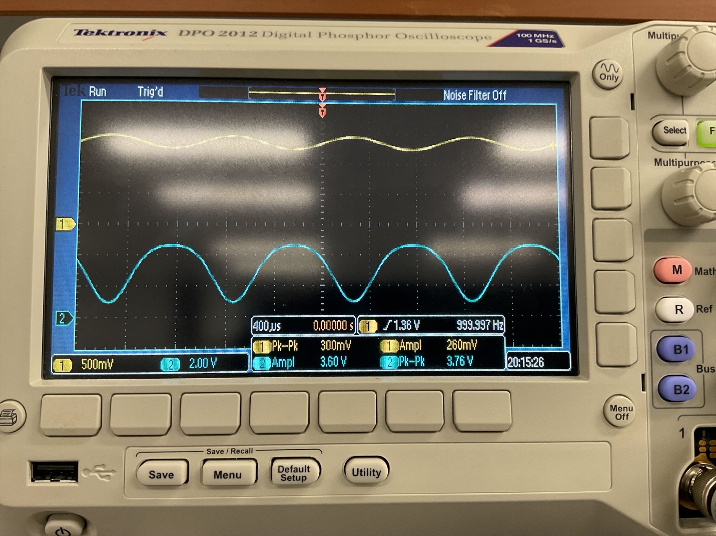

12.
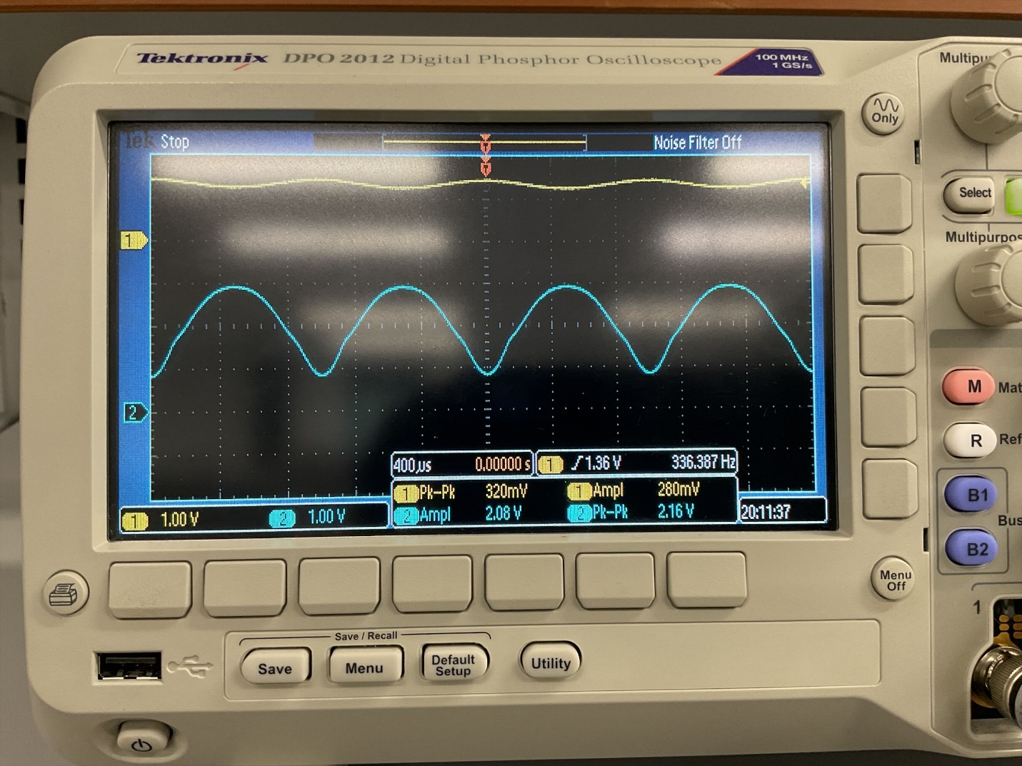

Task 3.
Both MOSFETS have a Vth of 1.5 V
2.
Resistor | 100 ohms | 500 ohms
Vg2 | 3.85 V | 4.05 V

3.
Resistor | 100 ohms | 500 ohms
Rd | 1200 | 1000

4.
Voltage | 100 ohms | 500 ohms
Vg1 | 1.38 V | 1.38 V

5.
Resistors | R = 100 ohms | R = 500 ohms
R1 | 26000 | 26000
R2 | 10000 | 10000

6.
 | Rd = 1000 ohms | Rd = 1200 ohms
Stage 1: Av = -gmRs | -10 | -12
Stage 2: gmRs/1+gmRs | .9 | .98

7. C = 1/((2pi)(1000)(7222)) = 0.02 μF

8.
Voltage | 100 ohms | 500 ohms
Vgs1 | 1.39 V | 1.39 V
Vds1 | 3.5 V | 3.75 V

9.
Voltage | 100 ohms | 500 ohms
Vs2 | 2.05 V | 2.35 V
Vds2 | 2.95 V | 2.65 V
Vgs2 | 1.45 V | 1.39 V

11.
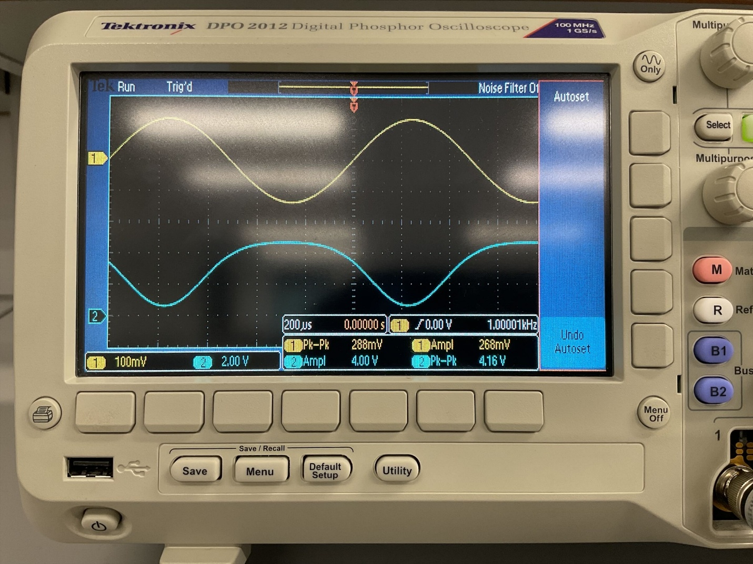
12.
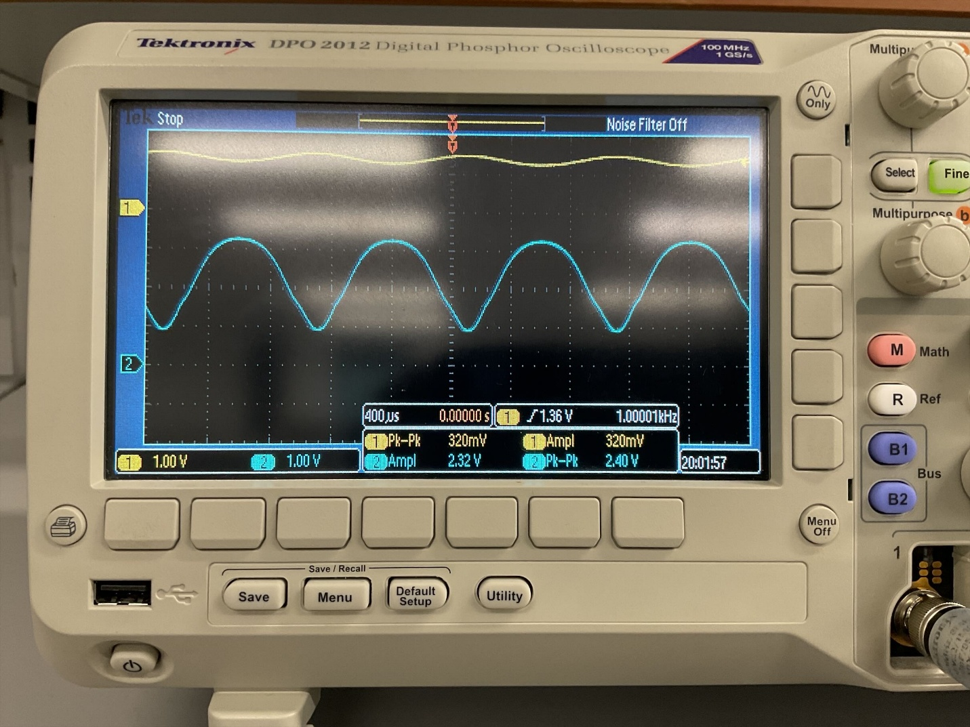

13. This circuit amplifies an AC input signal in the common source stage and then uses the common drain stage to drive an LED. The common drain stage was chosen for its low output impedance, which allowed it to deliver the required current to the LED without a significant voltage drop.

The red and green LEDs each acted differently due to their different voltage requirements. The green LED required a higher voltage to reach the same brightness level as the red LED. This led to the green LED also having a lower current for the same resistor value.
Between the two resistors, the 100 ohm resistor produced a higher current, making it brighter, while the 500 ohm resistor limited the current and reduced the brightness. The tradeoff here is that the 500 ohm resistor allowed the second stage to remain in a more linear region, while the 100 ohm resistor created a larger voltage drop across the load. The 500 ohm resistor sacrificed brightness for a more stable DC operating point
Conclusion:
This lab showed how to combine the low output impedance of a common-drain driver with the voltage gain of a common-source stage to create a two-stage MOSFET amplifier that can drive an LED. Each stage's DC biasing established the current that ultimately regulated LED brightness as well as the transistors' operating region. While the common-drain stage supplied the current needed by the LED without interfering with the first stage, the common-source stage generated the anticipated voltage gain. The forward voltages of the red and green LEDs differed, shifting the bias point and altering the current flowing through the load. Overall, the measured outcomes matched the amplifier's anticipated small-signal behavior.

